**Do work on the assignment below**

**All the best !**

**Instructions**

1. Create Knowledge ai and dialogs in same bot
2. Ensure no wrong intent detection happens if an utterance is entered
3. Use ML as much as possible and use patterns only if required
4. Create a batch suite by coming up with test utterances with variations and the score should be at least > 90%
5. I expect ambiguity to show up for similar responses or for vague utterances.
6. Think from end user perspective while training
7. Assignment should be shared with me and Ramesh srinivasan by Dec 06 EOD for review. Give us access to the bot

**FAQs:**

Click on the link https://support.skype.com/en/faq/FA34713/faq-and-known-issues-with-skype and then click each of the below section to pick FAQs to be added into Knoweldge.ai

* FAQ and known issues in Skype on Android 6.0 - 7.1.2
* FAQ and known issues in Skype on iOS and Android (8.0+)
* FAQ and known issues in Skype for Desktop, Mac, Linux, and Web

**Dialogs ( do ML training and can use FM engine only if really required to avoid conflicts )**

Click on link <https://support.microsoft.com/en-us/skype-for-business> .

2 use cases:

1. Click on "call" button.

* Create a "call" dialog with an entity node to have these buttons

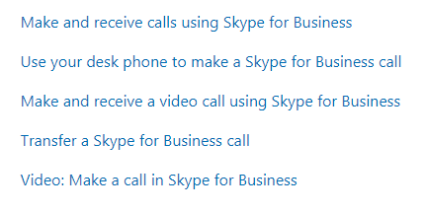

* When an user enters utterance such as "how do i place a video call" then it should be able to extract entity and give appropriate response
* Click on a specific hyperlink to handle bot response.
* Bot responses can be just the 1st paragraph you find upon clicking on the hyperlink. ex: for "make and recive calls" just enter first para as response

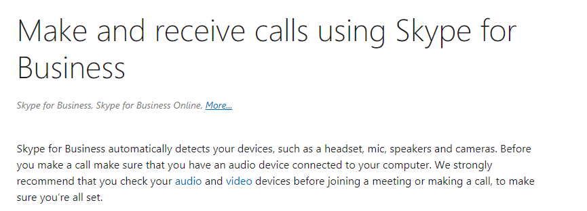

2. click on "chat" button

* Create a "chat" dialog with an entity node to have these buttons

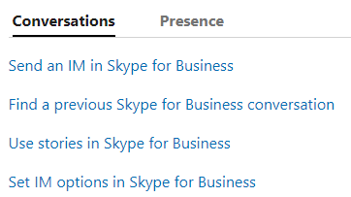

* Follow rest of the instructions to construct dialog as mentioned in above use case